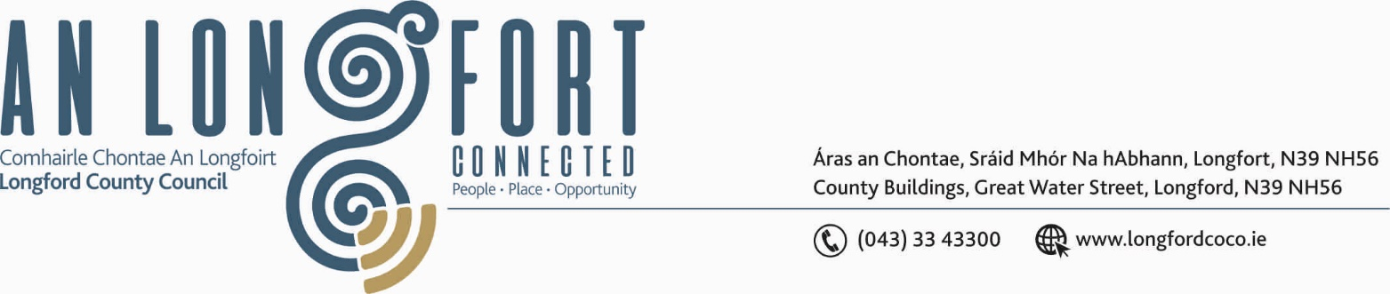

BALLYMAHON MUNICIPAL DISTRICT

27th April 2018.

To: Each Member of Ballymahon Municipal District.

Dear Member,

You are requested to attend Meeting of Ballymahon Municipal District to be held in Ballymahon Community Library on Thursday, 3rd May 2018 at 4.00 p.m. to transact business, as set out on the Agenda hereunder.

Yours sincerely,
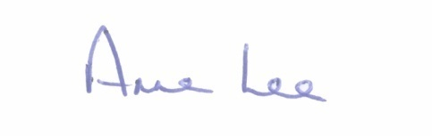

_______________
Anne Lee,
Meetings Administrator.

AGENDA

Prayer before meeting.

1. Confirmation of Minutes of the following Meetings of Ballymahon Municipal District -

- Committee Meeting held on the 22nd March 2018.
- March Meeting held on the 22nd March 2018.
- copies enclosed.

2. Matters arising from Minutes.

3. Management Report - to follow.

4. Funding of Burial Grounds - report to follow.

5. Consideration of applications for funding under the 2018 Community Grant Support Scheme.

6. Update on Projects for funding from Capital Reserves 2018.

7. Notices of Motions submitted by Councillors, as listed hereunder –

Councillor Paul Ross.

“That Lighting be installed outside Scoil Bhride, Glen in the interest of public safety.

Councillor Gerard Farrell.

That Longford County Council addresses the bottle neck on the road at Tullyverane, Lanesboro between Patsy Leavy’s house and
Regina Morrissey’s house as this is the main road to Fermoyle Schooland needs to be upgraded.”

“That Longford County Council addresses the drainage problem at Patsy Leaveys, Tullyverane.”

Councillor Pat O’Toole.

“To ask Longford County Council to consider building a further 8 to 10 Older Persons Dwellings in Ballymahon to meet current demand.”

“ I call on Longford County Council to consider, on a phased basis, the retrofitting of doors and windows in all houses in St. Matthew's Park, Ballymahon.”

8. A.O.B.

